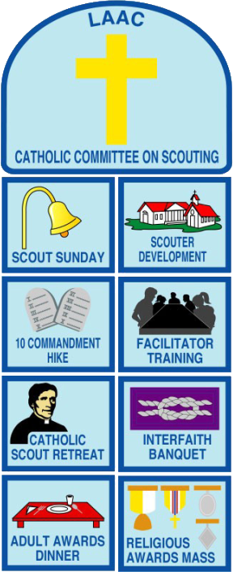
Large Patch: | $5.00 ea
Small Patches: | $2.00 ea
Complete Set: | $21.00 ea

For more information on the Catholic Committee,
contact:

Cathy Moreno
(562) 355-6658
cmorenobsa@gmail.com

Order Form

Item | Qty |  |  | Each |  |  | Total
Complete Set |  |  | x | $21.00 | = | $
Large Patch |  |  | x | $5.00 | = | $
Small Patch |  |  | x | $2.00 | = | $
Indicate small patches below –
e.g. 10 Commandment Hike, Scout Retreat, etc.
 | Shipping (included) |  |  |  |  |  | --
 | Grand Total |  |  |  |  | $

Make check payable to “GLAAC Catholic Committee on Scouting.”

Ordered by

Name:
Address:
City: |  |  |  |  |  | State: |  |  |  | ZIP:
Home Phone:  (include area code) |  |  |  |  |  |  |  | Cell Phone:  (include area code)
E-mail Address:

Mail this form and payment to:

Cathy Moreno
15740 Birchwood St.
La Mirada, CA 90638

